

User Requirement Specifications for
JOHOR PORT BERHAD
(253394-D)

Unsafe Action Unsafe Condition
(UCUA)

05 October 2024
Table of Contents

Table of Contents
1 Preface 3
1.1 Introduction 3
1.2 Problem Statement 3
1.3 Intended User 3
1.4 Acronyms and Abbreviations 4
1.4.1 General Descriptions 5
1.4.2 Specific Requirement 7
2 UCUA Flowchart 8
2.1 UCUA Main Flowchart 8
2.2 Unsafe Action Flowchart 9
2.3 Unsafe Condition Flowchart 11
2.1.2 UCUA Penalty Matrix System 13
3 Expectation Duration for System Development 15
Appendix A 16

DOCUMENT SIGNED-OFF
Document Acceptance Form
JOHOR PORT BERHAD (JPB)
Prepared By
Name | Signature | Date
Khairi bin Md.Juri
Nur Syahirah Binti Zulkerneian
Nurul Aishah binti Shairatulikram

PSSD Reviewed & Verified By
Name | Signature | Date
Dr. Mohamad Arizal Bin Ali

Noor Azah Ismail
Nor Zaini Mohamad

Approved By
Name | Designation | Signature | Date
Jamaludin Raja Mohammad | General Manager

Preface

Introduction
This document is a User Requirement Specification (URS) that contains details about Unsafe Condition Unsafe Action (UCUA). The purpose of this paper is to be a guidance or reference for the design, development, and implementation of a system in this project.
UCUA is a form complaint system that is used in Port Security & Safety Department (PSSD) to process, distribute, and complete report forms for unsafe conditions and unsafe actions. The current process of form that is used is the traditional paper-based process, but web-based forms are becoming efficient for capturing information, keeping track, and gathering data analysis.

Problem Statement
Through observation on the current process for users to submit a complaint report to PSSD department, several problems have been identified including:
- Request must be done manually by submitting physical form
- Might take few times to submit, respond and process the form
- Involve costs for paper usage, printer toner, filing accessories and physical storage
- Hard to find or track previous records
- Possible loss of document

Intended User
This document is intended to be read by:
- Internal user
- Port Security & Safety Department (PSSD)

Acronyms and Abbreviations
Throughout this document, the acronyms or abbreviations used are as follow:
Acronym | Description
PPE | Personal Protective Equipment
JPB | Johor Port Berhad
Operation Areas | Wharves, terminals, JPB operated warehouses, jetties including DCJ’s areas and any maintenance, service or construction activities inside Johor Port excluding leases and tenant’s compound.
Port Community | All Port Users but not limited to: Staff, Tenants, & Leases, Customers, Contractors, Visitors, Suppliers, Government Agencies, Regulatory Bodies, and other stakeholders.
PSSD | Port Security & Safety Department
BBT | Bulk and Break Bulk
JCT | Johor Container Terminal
JPL | JP Logistics
DCJ | Dangerous Cargo Jetty
OJ | Oil Jetty
HIRADC | Hazard Identification, Risk Assessment and Determine Control
UCUA | Unsafe Condition Unsafe Action
HOS | Head of Section
GM | General Manager
HSE | Health Safety Environment

General Descriptions

Objectives
The objectives of this project are as follow:
- To provide all port communities with an online system that is able to gather, retrieve, and trace/detect information on:
- The complainer/offender
- The feedback
- Number of offences
- To alert OSH team and other related department on any complaint.
- Manual to paperless

Scope
The proposed software product is the Unsafe Condition Unsafe Action (UCUA), The system will be used in Johor Port Berhad (JPB) particularly for Port Security & Safety Department.
Scopes of work for user are as follow (software & hardware):
- Accessible to apply, check, verify, process, monitor, record, administrate and manage feedback.
- User can keep track and view previous history of complaint.
- User can upload the picture that needed for evidence and as references.
- Generate report and analysis based on the complaint. The list of suggested report and analysis are as follows:
- The complainer/offender
- The feedback
- Number of offences
- GUI-based or web-based system.

UCUA Users
The users are listed as follow:
- External User:
- Observer:
- Public User: Vendors
- JPB Staff
- Others related department

- Internal User:
- Admin:
- Port Security & Safety Department (HSE PSSD)
- General Manager (GM)
- Head of Section (HOS PSSD)

Specific Requirement

Overview of Overall Process Manually (High level)

PSSD Process
(Verification)Observers submit a report

PSSD compile & verify the form and need to determine the follow-up action for the violator. Observer submits a paper-based form to Port Security & Safety Department (PSSD).

PSSD Process
(Approval)

Proceed to PSSD General Manager (GM), Head of Section (HOS) and any respective authority for approval (manual sign).

UCUA Flowchart

2.1 UCUA Main Flowchart
The major activity that has been executed in form of flowchart by PSSD are being defined in figure below and in Appendix A.

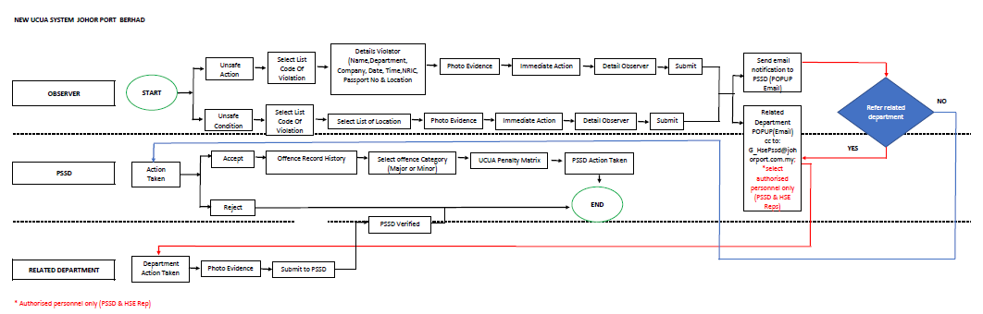
Figure 2.1 UCUA Main Flowhart

2.2 Unsafe Action Flowchart
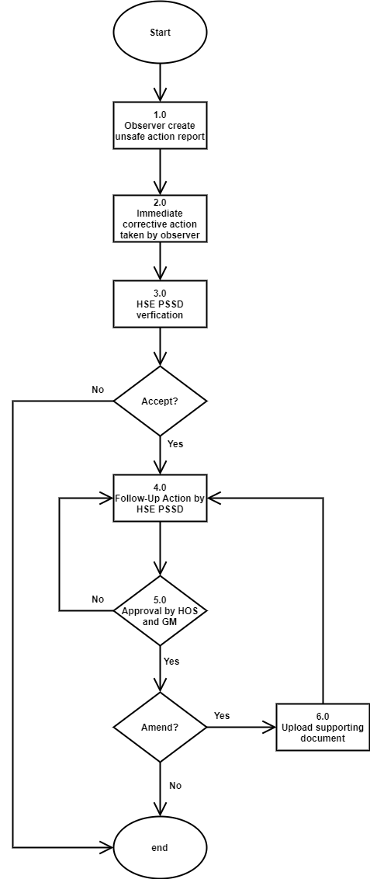
Figure 2.2: Unsafe Action Main Flowchart
Table 2.1 below shows the description of the Unsafe Action main flowchart.
Table 2.1: Description of Unsafe Action Main Flowchart
No | Item | Description
1.0 | Observers create unsafe action report | Observers create and fills in all details for the Unsafe Action Form that is required via UCUA an online form management. The details as follows:  - Location of the offences  - Offence code  - Photo Evidence  - Observer details:  - Name  - Department  - Date and time  - Violator details:  - Name  - Staff/IC/Passport Number  - Company  - Date and time  If the observer is an HSE REPS, the HSE Details that need to be fill in as follows:  - HSE REPS/PIC details:  - Name  - Department  - Date and time
2.0 | Immediate corrective action taken by observer | Observers needs to select the immediate corrective action taken to the violator. The immediate corrective action taken are based on user role:  - Public user and JPB Staff:  - Stop Work  - Verbal Warning (Supervisor and above)  - Notify Related Parties  - Others  - HSE PSSD:  - Stop Work  - Verbal Warning  - Revoke Entry Permit  - Notify Related Parties  - Others
3.0 | HSE PSSD verification | HSE PSSD responds whether the application is approved or rejected.
4.0 | Follow-up action by HSE PSSD | HSE PSSD need to refer UCUA penalty matrix as shown in Figure 2.4. Penalty will be determined based on the penalty matrix and violator history.
5.0 | Approval by HOS and GM PSSD | The report needs to be reviewed by the Head of Section and approved by GM PSSD.
7.0 | Upload supporting document report | If there is amend from the violators, they need to upload the supporting document in the system and then HSE PSSD need to follow-up the action. The new follow-up action needs to be approved again by HOS and GM PSSD

2.3 Unsafe Condition Flowchart
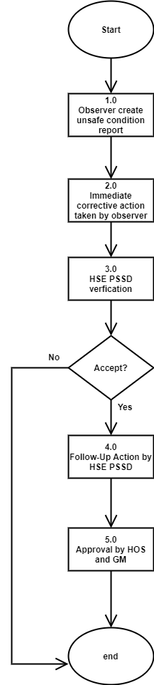

Figure 2.3 Unsafe Action Main Flowchart

Table 2.2 below shows the description of the Unsafe Condition main flowchart.
Table 2.2: Description of Unsafe Condition Main Flowchart

No | Item | Description
1.0 | Observers create unsafe condition report | Observers create and fills in all details for the Unsafe Condition Form that is required via UCUA an online form management. The details as follows:  - Location  - Offence code  - Photo Evidence  - Observer details:  - Name  - Department  - Date and time  If the observer is an HSE REPS, the HSE Details that need to be fill in as follows:  - HSE REPS/PIC details:  - Name  - Department  - Date and time
2.0 | Immediate corrective action taken by observer | Observers needs to select the immediate corrective action taken to the violator. The immediate corrective action taken are based on user role:  - Public user and JPB Staff:  - Stop Work  - Notify Related Parties  - HSE PSSD:  - Stop Work  - Notify Related Parties
3.0 | HSE PSSD verification | HSE PSSD responds whether the application is approved or rejected.
4.0 | Follow-up action by HSE PSSD | HSE PSSD need to refer UCUA penalty matrix as shown in Figure 2.4. Penalty will be determined based on the penalty matrix and violator history.
5.0 | Approval by HOS and GM PSSD | The report needs to be reviewed by the Head of Section and approved by GM PSSD.

2.1.2 UCUA Penalty Matrix System
The following matrix will be used to determine the offence consequence to the involved user. The penalty matrix of offences is shown in the figure below. Overall, there are 29 categories of offences with 17 major offences and 12 minor offences.
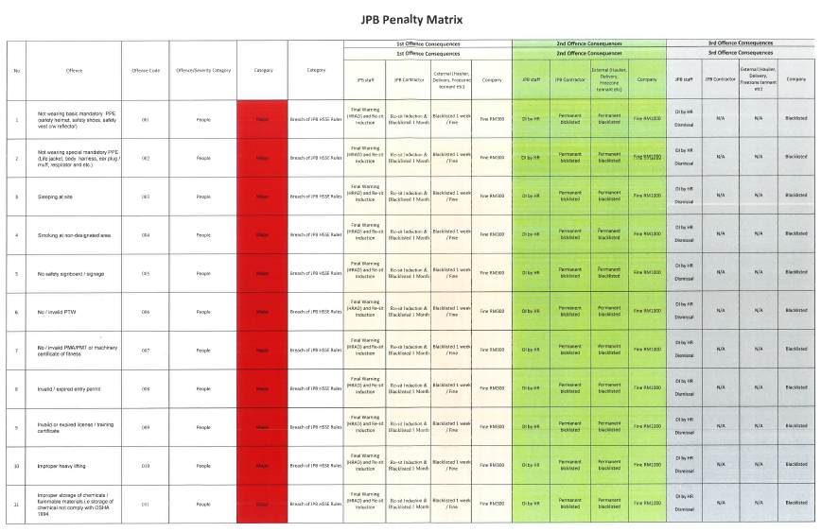
Figure 2.4: UCUA Penalty Matrix System

The category of offences is divided based on major or minor offences. Every offence has its offences code. The category of offence is shown in the figure below.
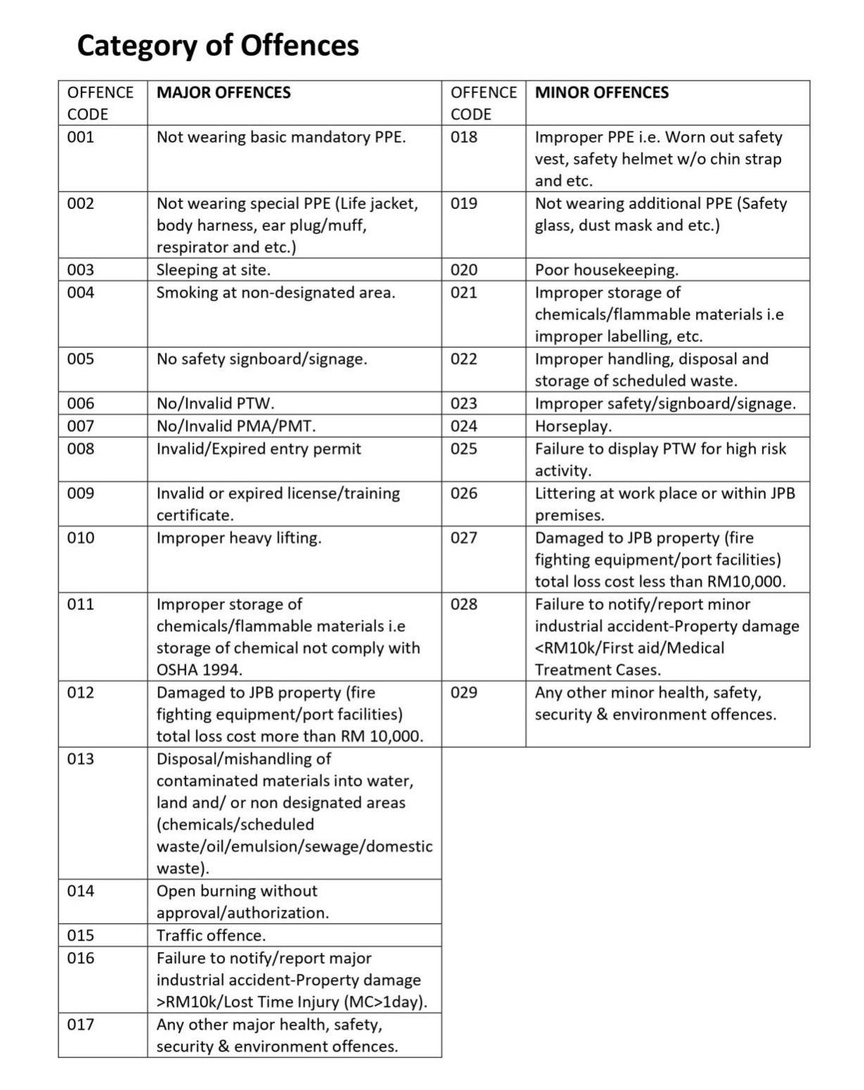
Figure 2.4: Category of offences

3 Expectation Duration for System Development
This timeline of project UCUA can be the guidance in development system. It lists some tasks or activity that to be performed in this project. This timeline also illustrate expectation start and finish duration of summary elements project.
No | Task / Activity | Sept  2021 | Oct  2021 | Nov  2021 | Dec  2021 | Jan  2022
1 | Gathering, analysis & documentation URS
2 | Gathering, analysis & documentation FTRS
3 | Designing graphical prototype
4 | Design actual prototype & internal testing
5 | Overall system development
6 | System internal testing, user acceptance testing
7 | Deployment & stabilization
8 | Pilot test and final acceptance test
9 | Roll out

Appendix A

